(Approx. 421 words)

Filter Out Junk Email with Outlook 2010
By Lynn Page, Editor, Crystal River Users Group, Florida
November 2013 Issue, CRUG Newsletter
www.crug.com
lpage46 (at) tampabay.rr.com

I have used Outlook for my email since my first version of Office (97). I keep my junk email protection level at high and have Outlook disable links in messages considered to be phishing and warn me about suspicious domain names.

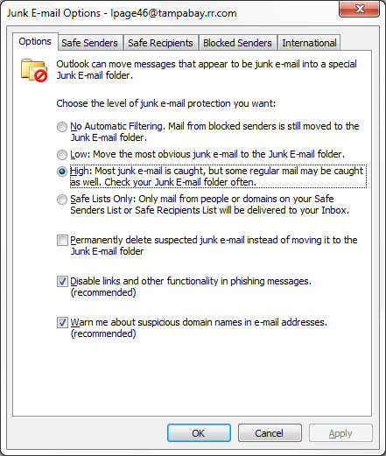
Outlook’s junk email filter is designed to keep spam and junk from getting to the inbox. It is on by default and will place the junk in its own folder. One of the default options is to have Outlook automatically delete suspected junk but it only takes a second to open the junk folder and glance to be sure something wanted didn’t end up there. I changed the filtering protection from the default level to high.

Junk Email Options
To control Junk Email options while in Mail on Home tab in the Delete group click the down arrow by Junk. On the dialog box Options tab select the level of protection desired. Selecting No Automatic Filtering turns the junk email filter off but you can still block senders and that email goes into the Junk folder.
The Safe Senders tab lists email addressed that you trust and have noted so. Email addresses and/or domain names in this list are never considered junk, regardless of message content.

The Safe Recipients tab lets you add specify an email address you use for a mailing or distribution list. All email sent to that address is never considered junk. I use this for my Corel PaintShop Pro Groups.

All email from addresses or domain names on the Blocked Senders list are automatically considered junk.

Add Senders to Safe Senders List
I mentioned that I keep the filter set to high so occasionally Outlook flags message I want as junk. That is not a problem. For an occasional email I simply drag it from the Junk to the Inbox. If the email is from someone I expect to continue to receive email from I add the address to the Safe Senders List. Simply select the email in the Junk folder and in the Junk drop down menu (Home tab Delete group) select Not Junk and respond as required.

Block a Sender
Conversely a few times email slips through from someone I do not know and I don’t want to continue receiving messages from them. In this case select the message an in the Junk drop down menu select Block Sender.

